Rules

1. All horses must have a negative Coggins to be on show grounds. This applies for companion horses also.
2. All riders must wear protective ASTM/SEI approved head gear.
3. River Boat Farms, Windswept Acres, Ken Zimmerman, employees, etc. **WILL NOT BE HELD RESPONSIBLE** for any damage, injury, or loss to persons, horse/pony or property of exhibitor or spectator incurred on or off the show grounds. It shall be a condition of entrance to the grounds that this is agreed*.*
4. River Boat Farms and Windswept Acres reserves the right to cancel, combine or otherwise alter classes.
5. Show management reserves the right to excuse any horse that is visibly unsound or in ill health, as well as any rider who demonstrates unsportsmanlike behavior.
6. No martingales in under saddle classes.
7. No draw reins permitted in classes.
8. Schooling in ring available 7:45 AM-8:15 AM and as indicated in schedules. Schooling breaks are ten minutes only; there will be a warm up ring available.
9. Refreshments will be available on the grounds.
10. All dogs must be leashed.
11. Six ribbons will be awarded in each class; Champion and Reserve ribbons in each division.
12. Fence heights are approximate.
13. The decision of the judge is final.
14. There will be a $15 schooling fee for all horses not registered in a class
15. There will be a $5 EMT fee.

ADDRESS DAY OF THE SHOW:

472 Manatawny Road

Boyertown PA 19512

**NOTE: do NOT send entries to farm address**

**When using a GPS do NOT take Spangsville Rd. There is a covered bridge and it can not handle the weight of a trailer.**

### 341 Stonetown Rd

Birdsboro PA 19508

www.windsweptacresatstonetown.com

**River Boat Farms and Windswept Acres present the Manatawny Hunter/ Jumper Series**

**2018 Show Dates**

**May 19\*\***

**June 16**

**July 14**

**September 15**

**October 13\*\***

**- FREEDOM RECOGNIZED

8:30 AM start

Jumpers not before 11:30

🙞 🙜

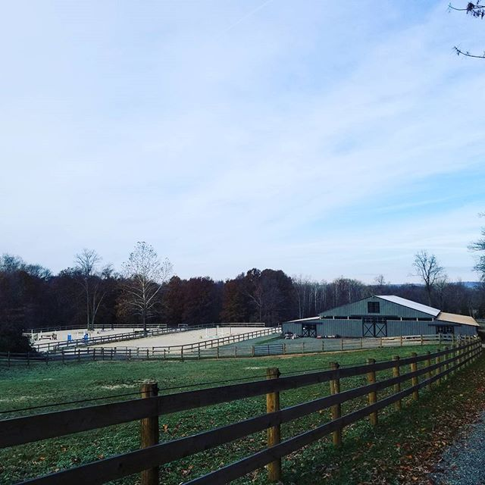

Sponsorship opportunities available.

* Cross rail Hunter and Hunter on the Flat not recognized by Freedom Horse Show Series

Judges

May 19- Gretchen Ober

June 16- Nancy Moffitt

July 14- Jo Emblin

September 15- Melissas Lyster

October 13- Jennifer Goss

Photography by Fino’s Photography

Preliminary Jumpers and Children’s/Adults Jumpers sponsored by Brookledge Horse Transportation

**SCHOOLING BREAK**

**_________________________________________**

Pleasure Horse/Pony (all ages) (ponies- 2’ Horses 2’6)

23. Walk/Trot

24. Walk/Trot/Canter

25. Over Fences #1

________________________________________________

**Children’s Hunter Pony**

26. Over Fences #1

27. Over Fences #2

28. Children’s Hunter Pony U/S

**SCHOOLING BREAK**

**Junior/Adult Equitation (All Ages) (2.3” – 2.6”)**

29. Over Fences #1

30. Over Fences #2

31. Open Equitation U/s

Low/Open Hunter (2’6”Ponies)( 2’9” Horses) Will split if entries warrant:  
32. Over Fences #1

33. Over Fences #2

34. Open Hunter U/s

**LUNCH/SCHOOLING BREAK NO EARLIER THAN**

**11:30 a.m. NO SCHOOLING JUMPER FENCES**

**Itty Bitty Jumpers – 2’ – 2’3”**

35. Itty Bitty Jumpers – Table II sec 2b

36. Itty Bitty Jumpers– Power and Speed

37.. Itty Bitty Jumpers – Table II sec. I (speed)

**Preliminary Jumpers – 2’6” – 2’9” Sponsored by Brookledge Horse Transportation**

38.. Preliminary Jumpers – Table II sec I (speed)

39. Preliminary Jumpers – Power and Speed

40. Preliminary Jumpers – Table II sec. 2b_

**Children’s/Adults Jumpers (professional pinned separate)– 3’ – 3’3” Sponsored by Brookledge Horse Transportation**

41. Child/Adult Jumpers– Table II sec 2b

42. Child/Adult Jumpers – Power and Speed

43. Child/Adult Jumpers – Table II sec. I (speed)

Leadline (under 6)

1. Leadline Walk

1. Leadline W/T
2. Leadline off lead

Walk/Trot Division (under 10)

4.Walk Equitation

5. Walk/Trot Equitation

6. Walk/Trot Pleasure

Beginner Rider-Open to anyone in their 1st or 2nd year showing):

7. Walk/Trot   
8. Walk/Trot/Canter  
9. Over Fences (4 Crossrails)_

Novice Equitation (2’)

(Open to riders who have not shown over higher than 2’):

10. Walk/Trot  
11. Walk/Trot/Canter

12. Over Fences (4 fences)

________________________________________

**SCHOOLING BREAK**

Hunter on the Flat*

13. Walk/Trot

14. Walk/Trot/halt

15. Walk/Trot/Canter

Cross Rail Hunter *

16. Walk/Trot

17. Walk/Trot/Canter

18. Over Fences

________________________________________

Baby Green Hunter (Horses in their 1st and 2nd year of showing) (Ponies- 2’ Horses– 2’3”)

19. Walk/Trot

20. Walk/Trot/Canter

21. Over Fences #1

22. Over Fences #2

Classes

**Physical Address is 472 Manatawny Road, Boyertown PA 19512- DO NOT SEND ENTRIES TO THE FARM ADDRESS!**

[**windsweptacrespa@hotmail.com**](mailto:winddweptacrespa@htmail.com) **for any quesstions**

**DIRECTIONS CAN BE OBTAINED BY CALLING 610-413-1447 or 610-223-0011. (do not take Spangsville Rd- there is a covered bridge)**

**PRE-ENTRIES MUST BE RECEIVED BY THE WEDNESDAY BEFORE THE SHOW, PRE-ENTRY $12/CLASS. ENTRIES THE DAY OF SHOW $15/CLASS. ENTRIES MAY BE MAILED TO Cyndi Gilbert 91 MEXICO ROAD; OLEY, PA; 19547. Checks made out to Cyndi Gilbert**

**PLEASE ADD A $5 SECRETARY FEE and a $5 EMT FEE TO YOUR ENTRY.**

**Rider: _______________________ DOB (If under 18): _________**

**Name of Horse: _________________________________________**

**Address: ______________________________________________**

**Phone: _______________________ E-mail: __________________**

**Classes: ____________________________________(PRE ENTRY $12 per class/ POST $15 per class/ $5 Secretary Fee/$5 EMT FEE)**

**Total $: ___________**

**Paid: Y/N Check #: ______________ Coggins: Y/N**

The undersigned agrees that River Boat farms, Windswept Acres, Ken Zimmerman, employees, etc. **WILL NOT BE HELD RESPONSIBLE** for any damage, injury, or loss to persons, horse/pony or property of exhibitor or spectator incurred on or off the show grounds. It shall be a condition of entrance to the grounds that this is agreed*.*

Signed (Rider): ________________________________________________________

Signed (Parent/Guardian if under 18): ______________________________________

Date: ________________

River Boat Farms and Windswept Acres Manatawny Hunter/Jumper Series Entry Form