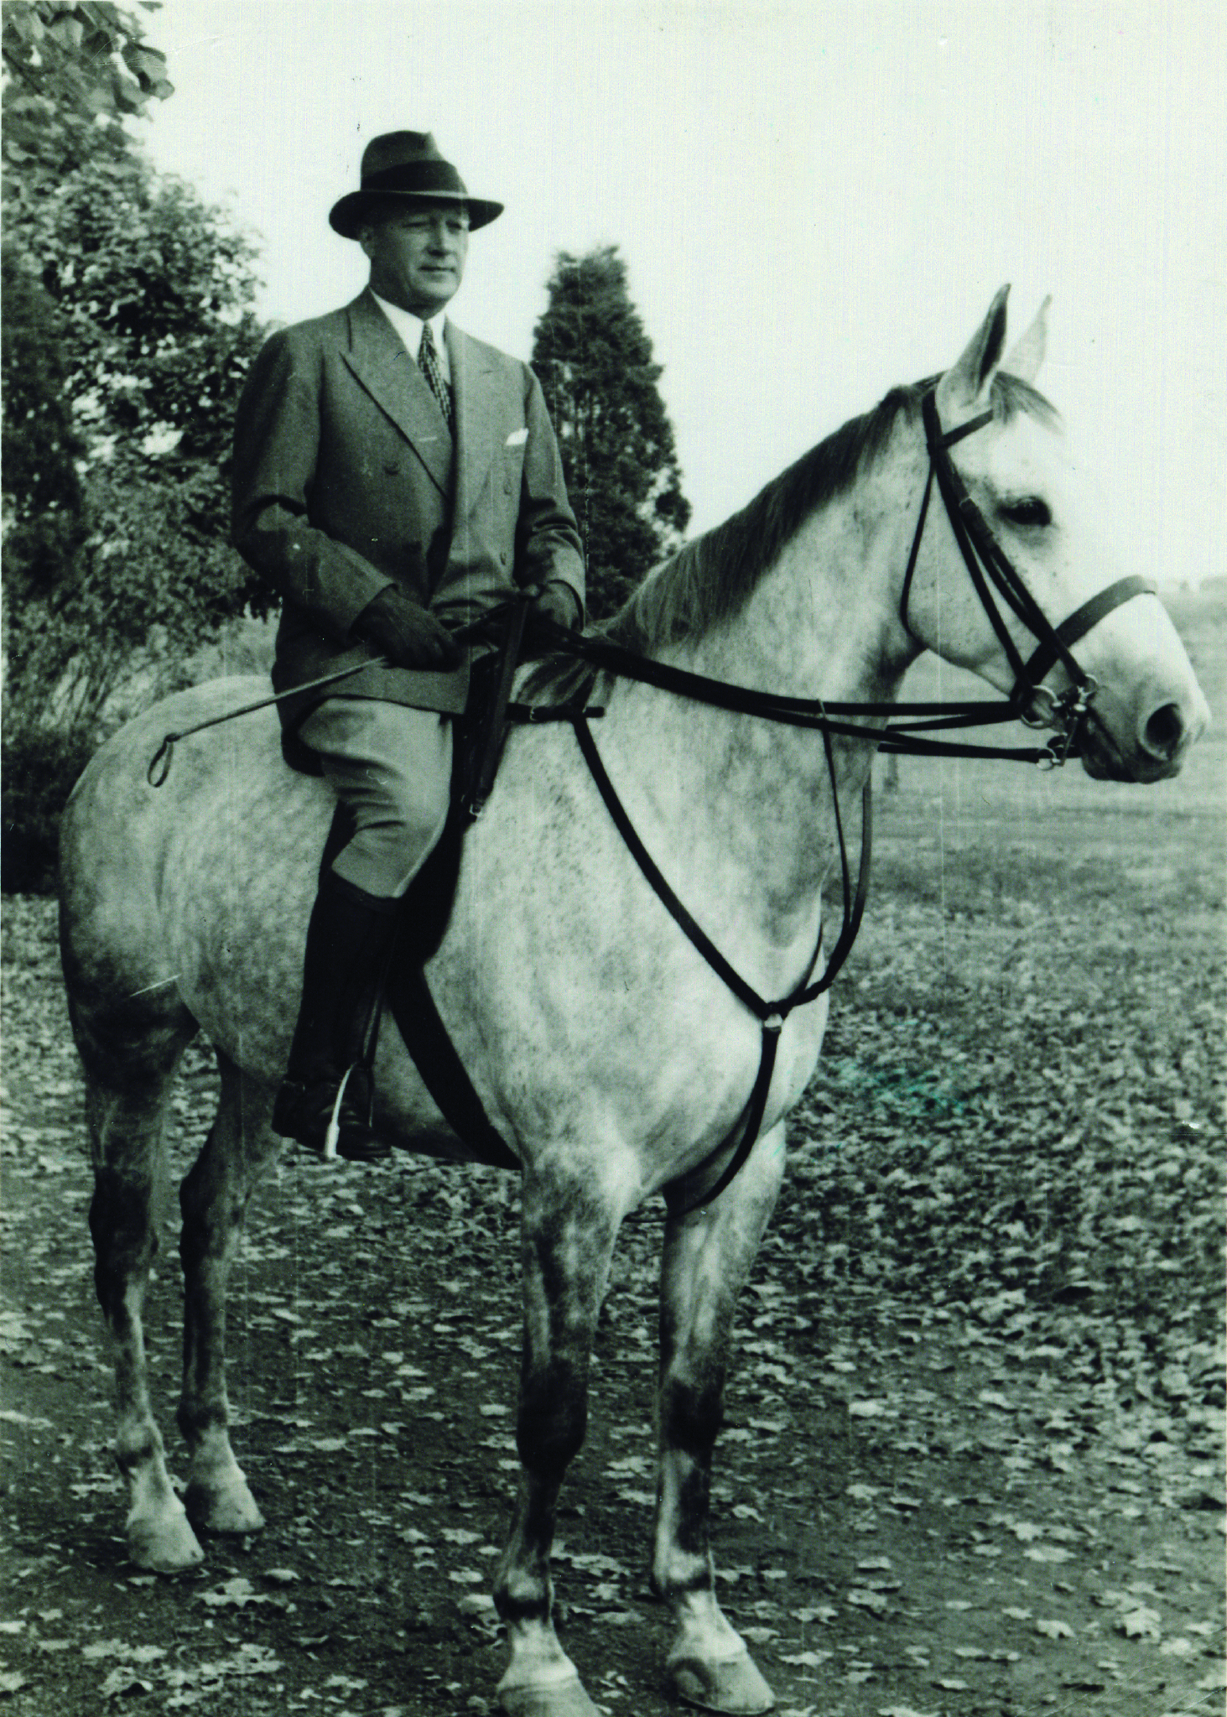  General Questions:  Please Contact:  Rebecca Mackey at  484-797-5031 Or  trminiprix@gmail.com  Please check us out on  Facebook and Instagram  @trminiprix  Please Mail Entry Blank to:  TR Mini Prix  1230 Pottstown Pike  Glenmoore, PA 19343 H.A. W. Myrin, founder of  Kimberton Farm School, 1941  An equestrian in his own right.  Please make checks payable to:  Kimberton Waldorf School.  Please Note for Mini Prix Dogs are welcome but  must be on a leash!  Directions:  From Phoenixville  Heading west on Route 23  Turn left on W. Seven Stars Road  From Elverson  Heading east on Route 23  Turn right on W. Seven Stars Road  Important: You assume the risk of equine activities pursuant to Pennsylvania law. Kimberton Waldorf School is not responsible for any damage, injury, or loss to any persons, horse, or property of any exhibitor, or spectator incurred on or off the grounds. |  |  | 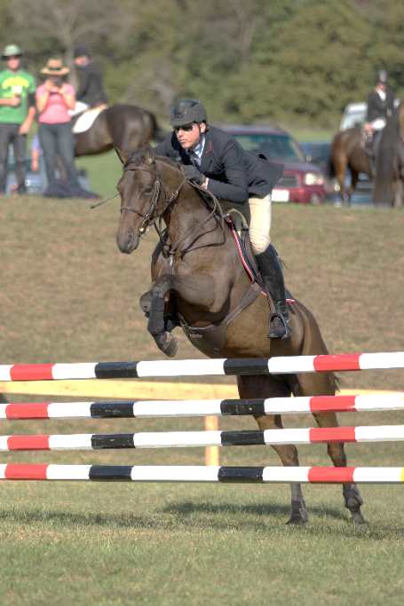  $2,500  Mini Prix  Sunday October 21, 2018  Rain or Shine  Closing Date: October 16, 2018  New Idea! Low Jumper Mini Prix  Sponsored by: T.R. Mini Prix $500  Benefit of:  Kimberton Waldorf School  410 W. Seven Stars Road  Phoenixville, PA 19460  [Company Name]  [Subtitle]
Committees:  Judge:  Dawn Corrado  Spring City, PA  Jump Steward:  Vince McDevitt  Kimberton, PA  Course Designer:  Tom McLean  Pottstown, Pa  Announcer:  Geof Williams  Nottingham, Pa  Secretary:  Rebecca Mackey  Michelle Mackey  Glenmoore, PA  Show Committee:  Tom McLean  Vince McDevitt  Rebecca Mackey  Official Timer……………………………………………………………………………..  Tami Dureka  Pottstown, PA  Back up timer……………………………………………………………..................  Kathleen DiCiurcio |  |  | Schedule of events:  TR Mini Prix is pleased to be a part of the “Freedom Show Series,” you will receive points from our June event and our October event towards high score from F.S.S!  8:00 AM: Low Jumper Mini Prix: Open to ponies and horses (juniors, adults, amateurs) with fences not to exceed 3’ Ft (2’6” to 2’9”) First round not for time, Only those without 2 refusals may come back for 2nd round at 2’9” – 3’. Time to count! Promptness is expected for order of go!  Pre-Entry: $35 (Limited to the first 25 entries)  Winner to the rider/horse or pony combination having the best time and the least amount of faults in the 1st and 2nd round combined.  No cross entry from this class to the $2,500 Mini Prix  11:00 AM Warm up Class (Open to all)  Table II2 B Timed first jumps off(3’6”-3’11”’,4’spreads)  Ribbons awarded to 1st through 10th place.  Pre-Enter: $30 Post Enter: $40  1:00 PM Mini Prix (Open to amateurs and juniors on any horse, professionals on a horse in their first or 2nd season of showing in 1.20m, as well as eventers on a horse competing up to 1.20 m)  Table II Section 2B Timed first jump off (3’9”-4’, 4’6” spreads)  Ribbons awarded to 1st to 10th place and prize money awarded to 1st through 8th place  Pre Enter: $125 Post Enter: $150  1st: $600.00 Perpetual Trophy to be engraved with Rider’s name and horse.  2nd: $500 3rd: $400  4th: $300. 5th: $225  6th: $175 7th: $150  8th: $150

